Memo to: Randy Larimer
From:
Regarding: EE 465-01, Lab 0 – Heartbeat LED

Summary:
The purpose of this lab was to use the HCS908QG microprocessor to flash an external LED at 0.5 Hz (one second on, one second off). This task was accomplished three ways: by using loops of counters, by using the “processor beans” tool to create a timing interrupt every one second, and by mixing the two techniques. The end result was a program which can exhibit a “heartbeat” for the HCS908.

Preliminary Solutions:
Referring to the flowcharts in Appendix A, the three solutions to this lab are fairly straightforward. In all three solutions, the port used to talk with the LED must be initialized for output. Also, the code for turning the LED on and off (output from the port) needs to be determined. In the first solution, shown by Figure A.1, this initialization is followed by a counter which increments on clock cycles to determine when one second has gone by, followed by turning the LED off. The counter block is reused before the LED is turned on again.
The second solution utilizes the processor beans to set up the timing interrupt. After the aforementioned initialization steps, the timer will fire an interrupt every one second, which will call the function to either turn the LED on or off.
The third solution is necessary due to constraints placed on the timing of the processor bean. Interrupts from the timer can be used, but they will not be in intervals of one second. Once the period of the interrupt is determined, a counter can be used to see when one second has gone by, similar to in solution one.

Setup:
To begin programming the 908, the chip was placed on the student learning kit (SLK) board, the VDD and VSS (GND) pins were set up with capacitors (as on p.26 of the HCS908 data sheet), VDD was set to 3.3V, a reset switch was wired to the RESET pin (pin 1) on the 908, and an LED on the SLK was wired to the PTA0 pin (pin 16). The BKG and RESET pins were wired to the corresponding slots on the SLK, to be used for downloading the firmware to the processor and debugging.

All Solutions – Initializing & Toggling LED
As mentioned in Setup, an external LED was wired to pin 16 on the 908, which corresponds to PTA0. Simply setting the least significant bit (LSB) in the Data Direction Register (DDR) for Port A to a one allows the use of PTA0 as output. The LED to which it was connected was active with logic high. Thus, writing a one to PTA0 would turn the LED on. To toggle the LED, the state of Port A was loaded into the accumulator; exclusive-ored with %00000001, which toggles only the state of the last bit, PTA0; and the result was stored into Port A.

First Solution – Counter Loops:
In order to use counters to determine when one second had passed, it was necessary to know how quickly the counter decrement process took to complete. By measuring this frequency (about 18.5MHz), the number of counter loops necessary to count out one second was calculated. The final design resulted in three loops: both nested loops used the 8-bit accumulator to count down from $FF (or 255 decimal) to zero; the outer loop then required only 15 iterations to achieve an overall one-second delay. It is worth noting that, within the first nested loop, it was necessary to “feed” the COP watchdog so that the processor would not reset. This was accomplished by using a predefined macro in the derivatives.inc file.

Second Solution – Processor Beans Timer Interrupts:
For the second solution, the beans utility was used to set up the timer interrupt from the timer pulse-width module (TPM). With the prescaler set to 128, the modulo counter set at 78D0, and the overflow interrupt enabled (see Figure A.4 in Appendix A), the timer would fire an interrupt every 946 ms. With the added bus cycles for other parts of the solution, this timing resulted in a 0.501-Hz flash from the LED – extremely close to the specified 0.5-Hz frequency.

Third Solution – Mix of Solutions 1 & 2:
Design constraints for the third solution dictated that the prescaler used in solution two be set at one. This necessitated the addition of a counter to take the place of the prescaler function. With the modulo timer set at its max, $FFFF, the LED flashed every 15.657ms, so a counter looping 60 times resulted in just under the ideal 946-ms delay achieved in solution two. This counter was created as a 2-byte variable in RAM, was initialized to 60, and was decremented by the timer IRQ. When the counter became zero, the LED state would be toggled and the counter would be reset to 60.

Summary Comments:
In performing this lab, several problems were encountered. None took more than an hour to troubleshoot, but the most bothersome was the requirement that the COP watchdog be “fed.” As the code initially did not do this, the 908 would put out strange signals as the timing grew towards the one-second delay mark. The simple remedy was to use the supplied feed_watchdog macro inside the delay loop.
Appendix A – Figures

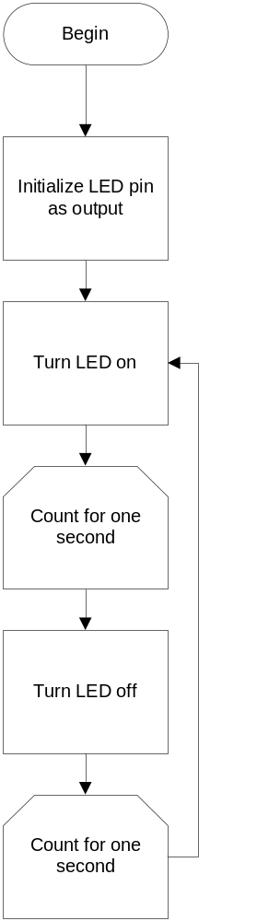  Figure A.1) Flowchart for the first solution, counter-based delay. | 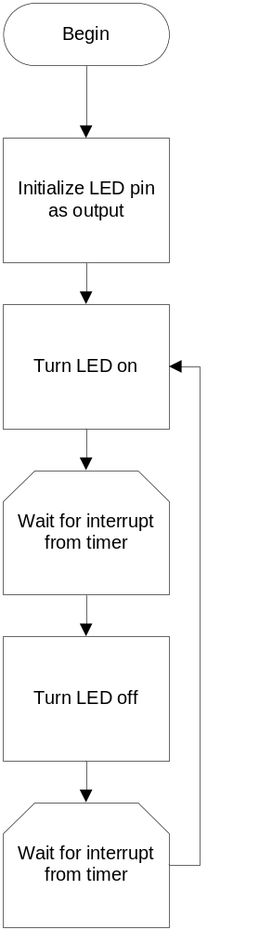  Figure A.2) Flowchart for the second solution, timer interrupt-based delay. | 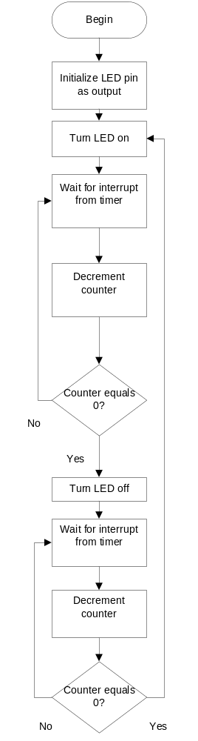  Figure A.3) Flowchart for the third solution, a mix of the first two solutions.

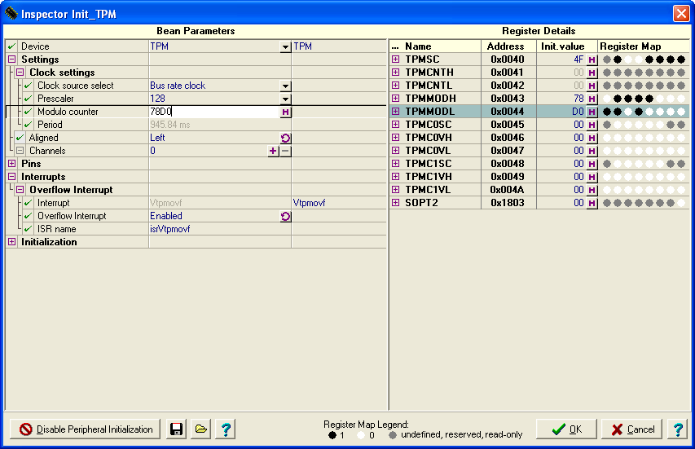
Figure A.4) Using the Processor Beans to set the timer interrupt.

